An Evening of Poetry and Music with Adam Zagajewski and Sarah Rothenberg
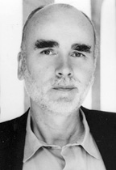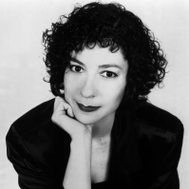
Thursday, November 17th, 5-7 p.m.
First Floor of Piper Hall
Loyola University Chicago Lakeshore Campus
1032 West Sheridan Road
(Parking available in Main Parking Structure, Lakeshore Campus)
Adam Zagajewski Poet, novelist, essayist Adam Zagajewski was born in Lwów in 1945. He first became well known as one of the leading poets of the Generation of '68' or the Polish New Wave (Nowa fala); he is one of Poland's most famous contemporary poets. His poem "Try To Praise The Mutilated World", printed in The New Yorker, became famous after the 11 September attacks.
Sarah Rothenberg Rothenberg is a pianist of “heart, intellect and fabulous technical resources” (Fanfare) and "a prolific and creative thinker" (Wall Street Journal) who is recognized internationally for her innovative multi-media performances linking music to literature and visual art.
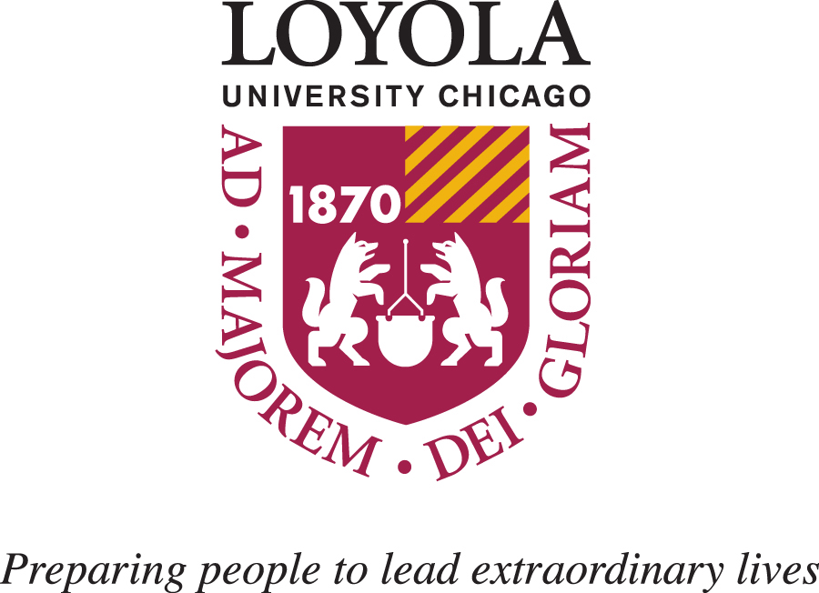
Reception and book signing will follow
Sponsored by: Polish Studies & Modern Languages and Literatures

